WS 11

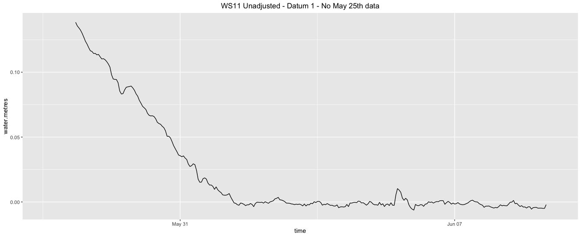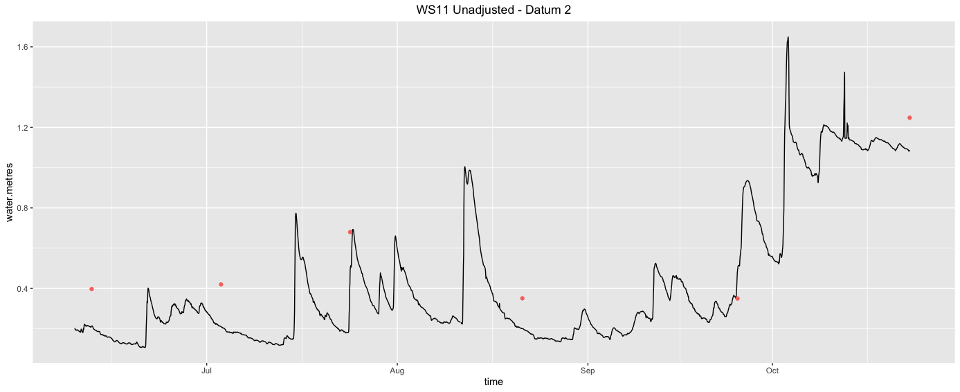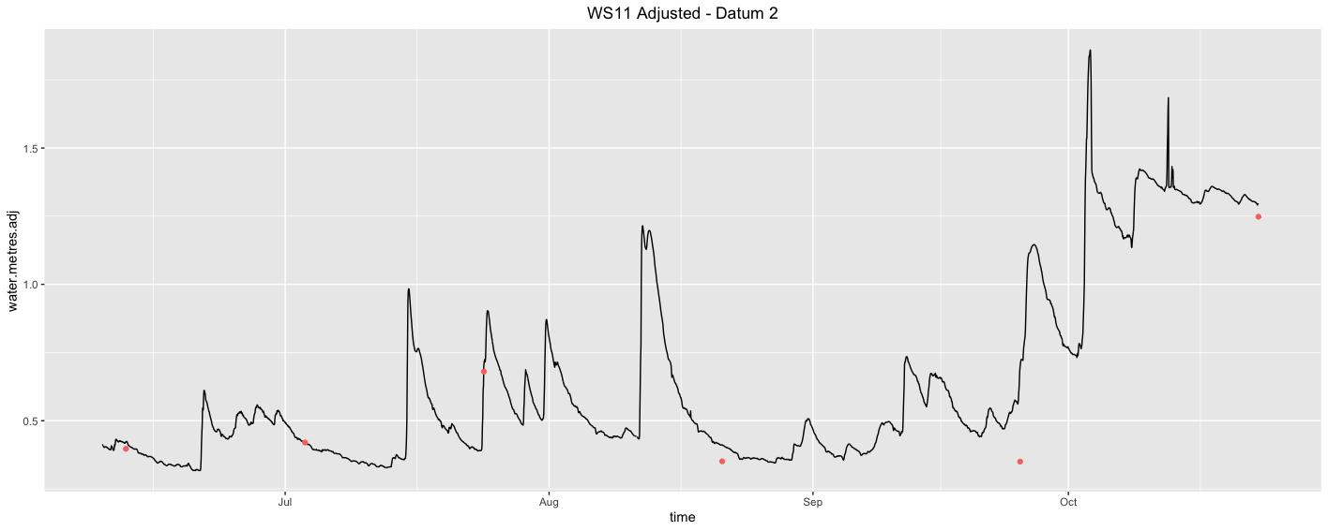

WS 17

WS SBC

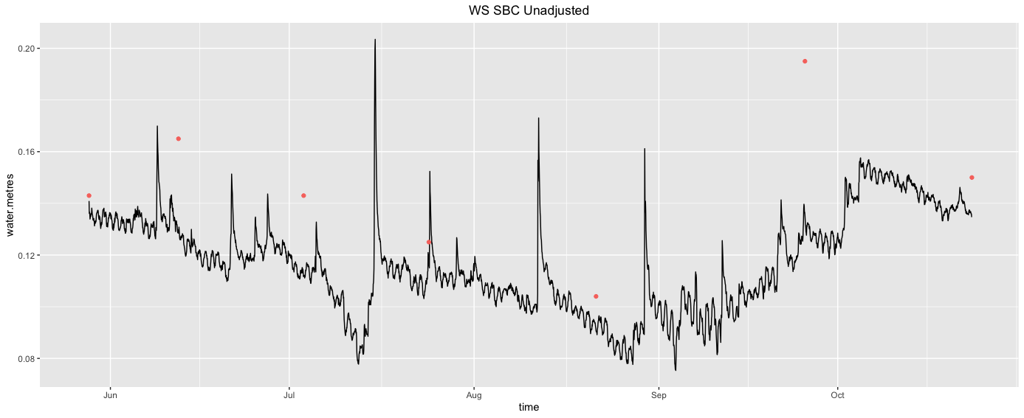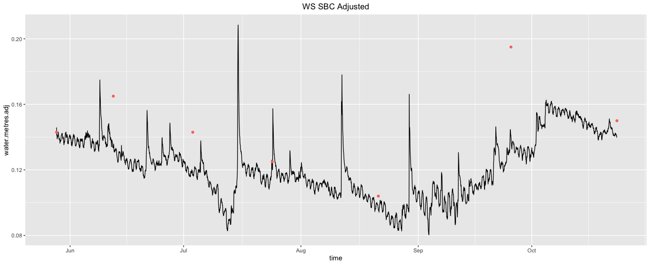

WS SSR

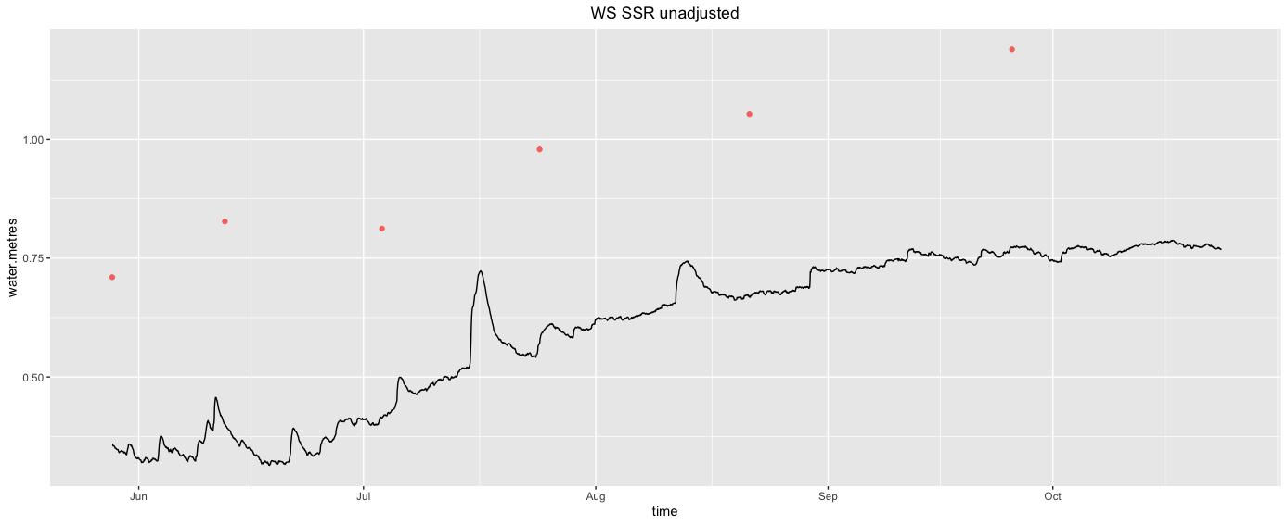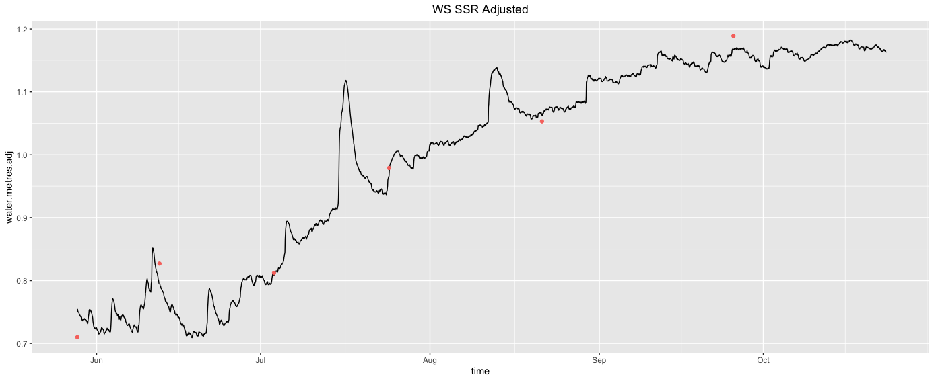

WS 54

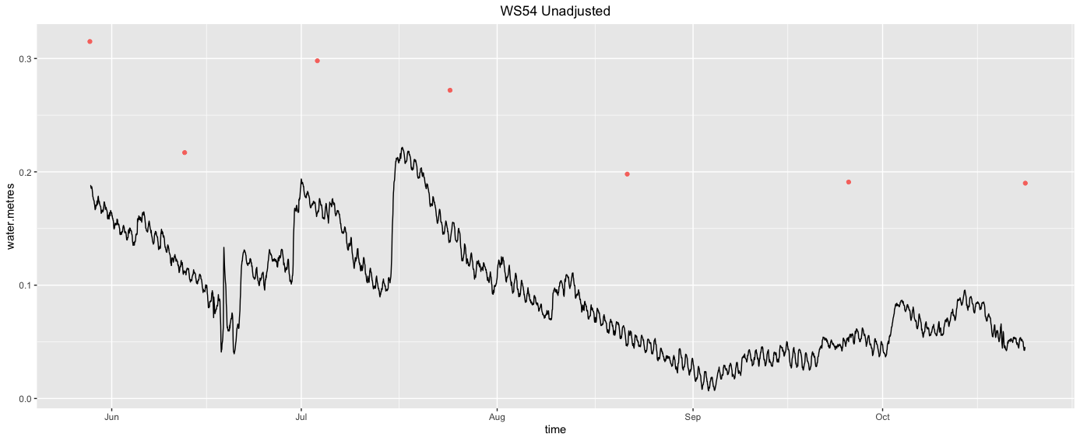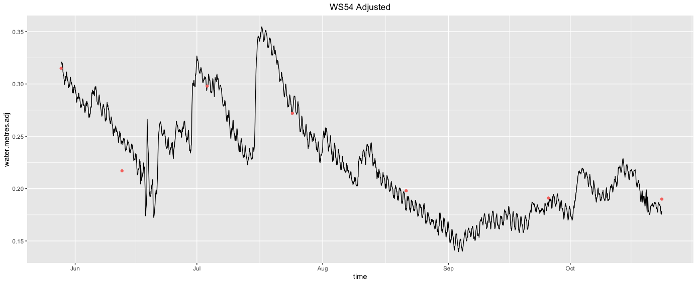

WS 52

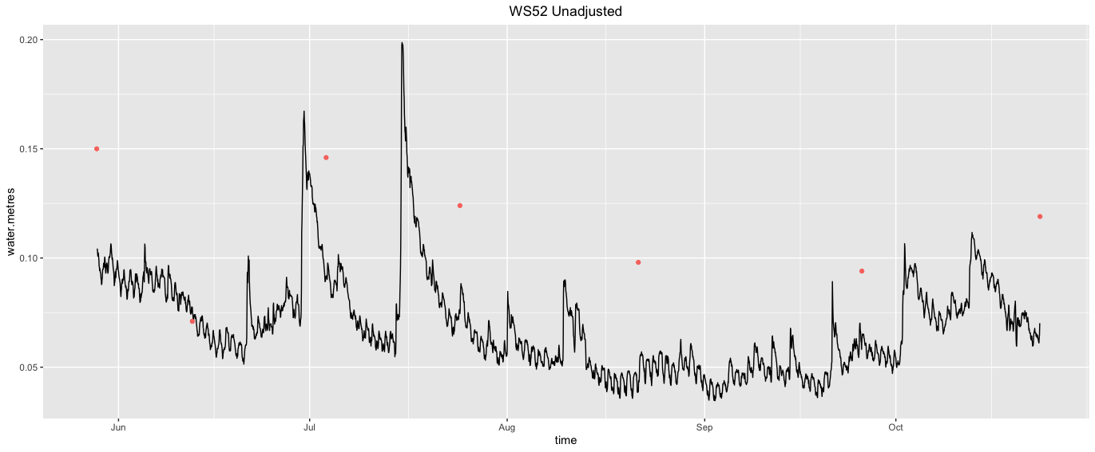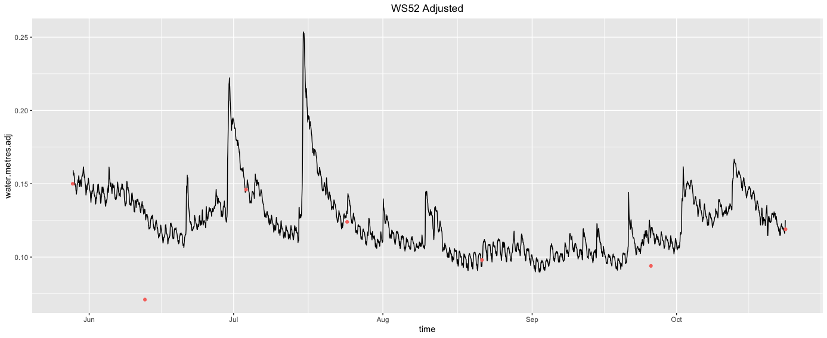

WS 47

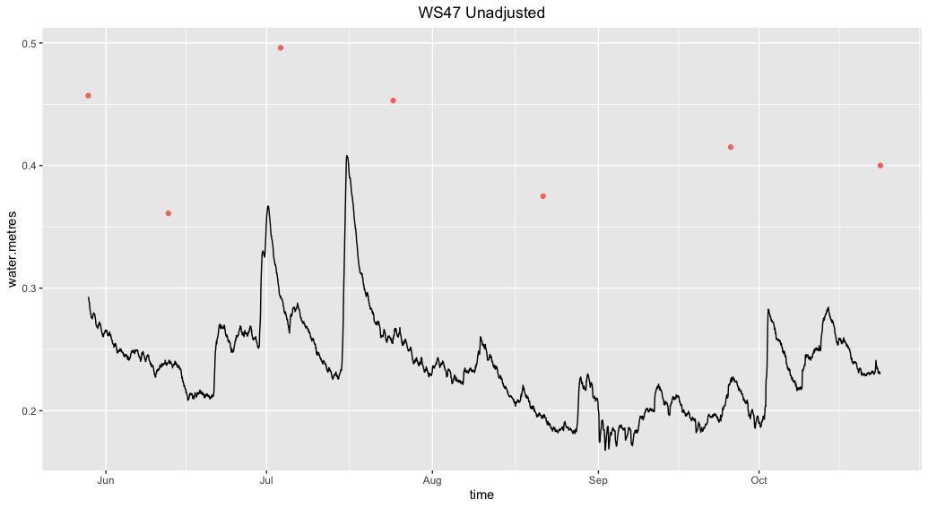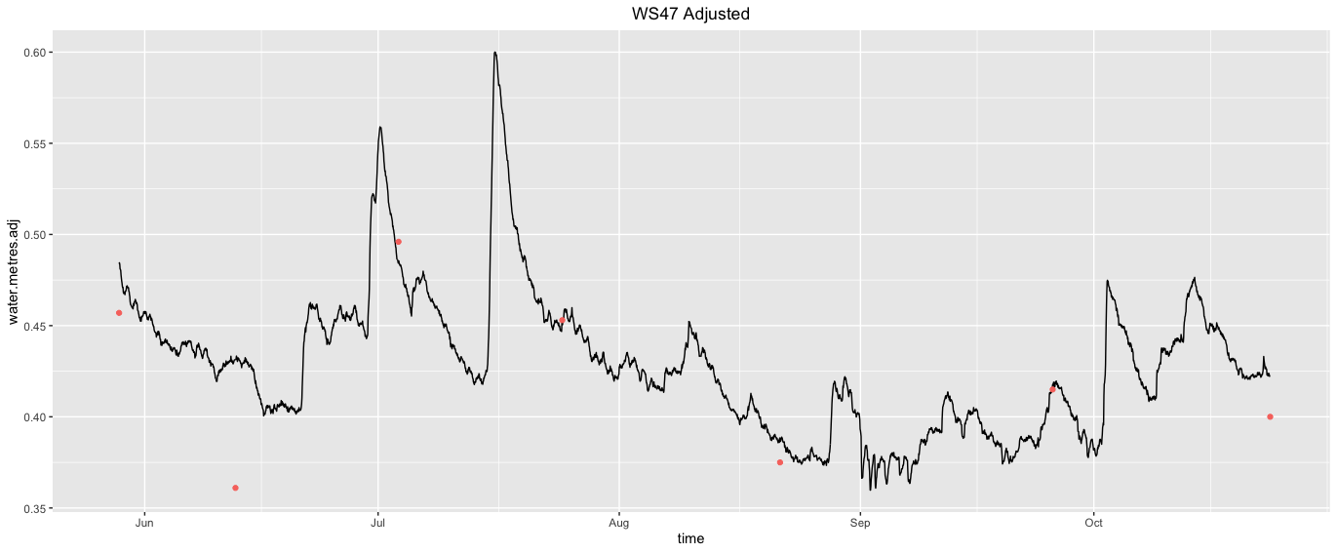

WS 46

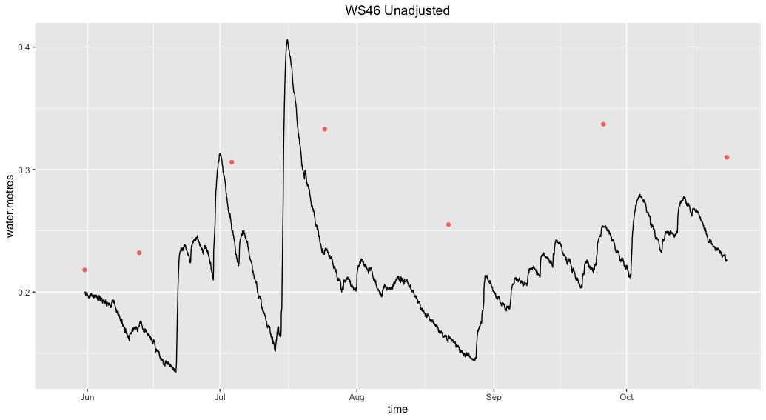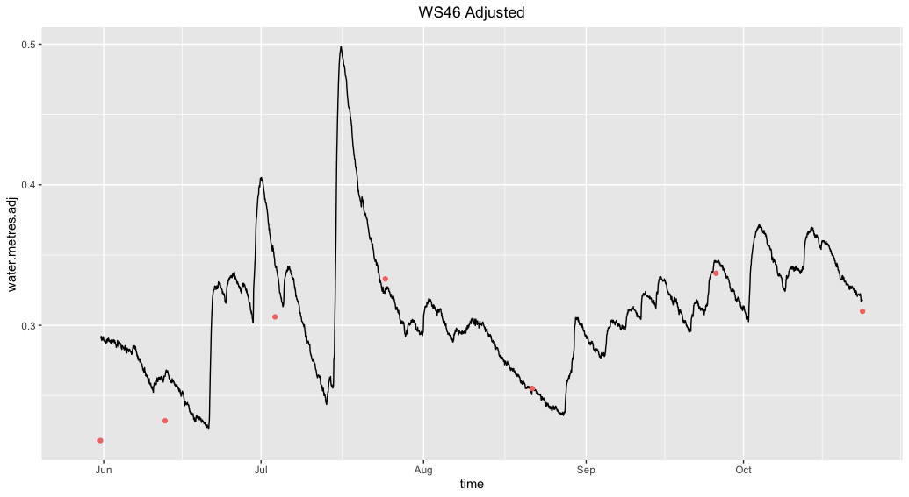

WS 45

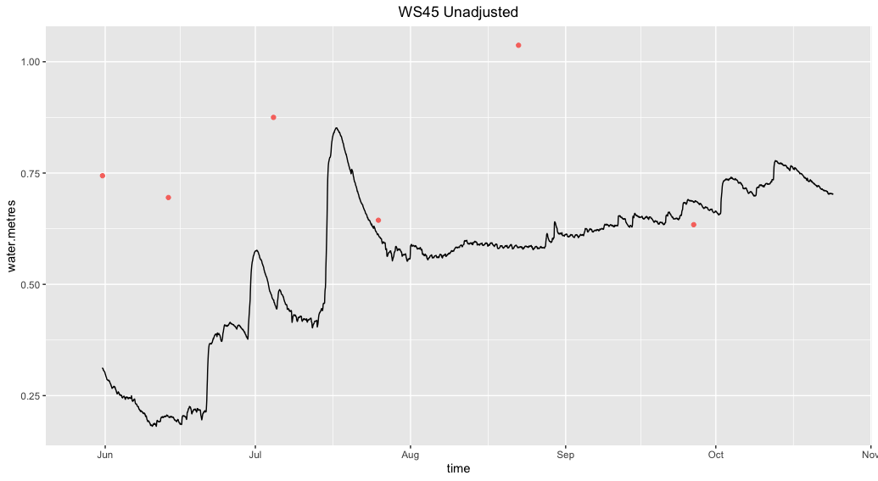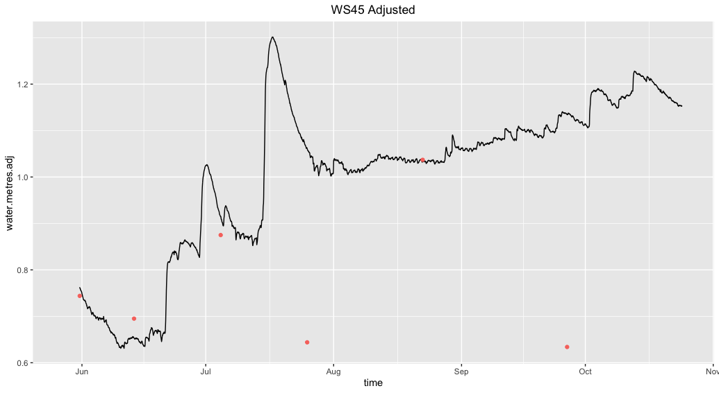

WS 44

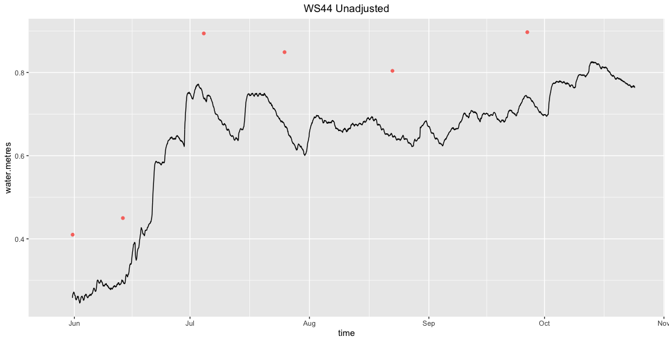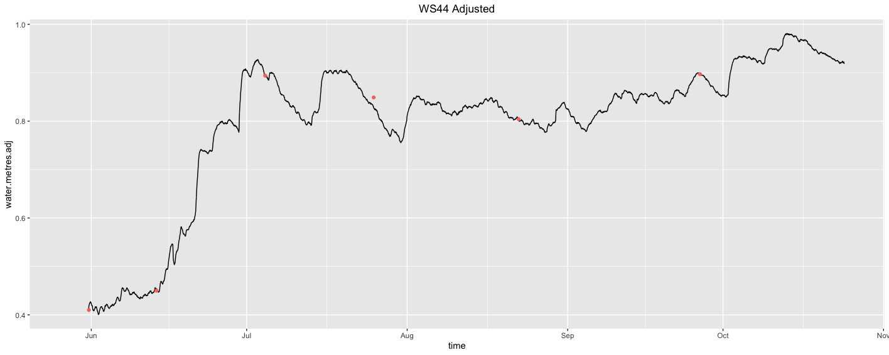

WS 43

WS 40

WS 36

WS 66

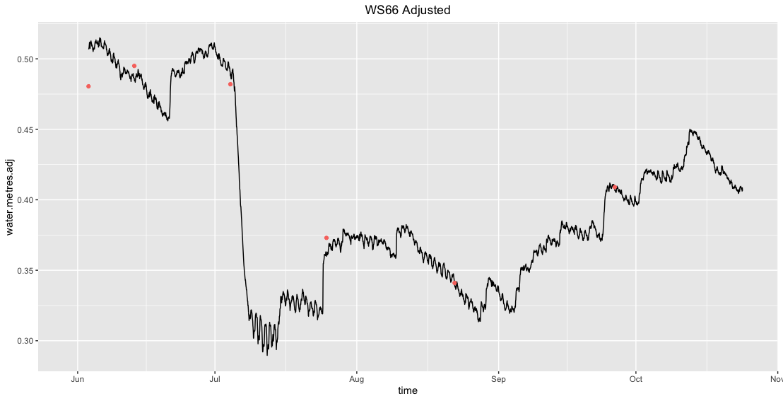

WS 67

WS BL1

WS BL2

WS 73

WS 75 – no Q estimate

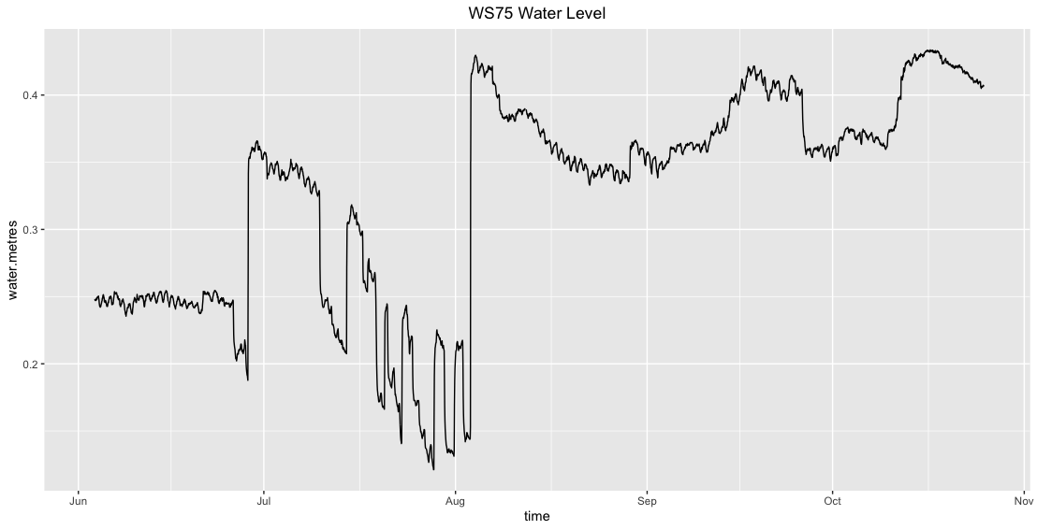

WS 76 & 77 – no Q estimate

WS 110

WS 84

WS 87

WS 82 – no Q estimate

WS 92

WS 93

WS 96

WS 104

WS 108

